Writing Data to the Text File
The following program demonstrates how to write data to the the file:
python101/Chapter-18/writing_to_file.py
1  2  3  4  5  6  7 | f = open("readme.md", "w")  f.write("First Line\n")  f.write("Second Line\n")  f.write("Third Line\n")  f.close()
In line 1, we are using open() method to open the text file in write mode. If the readme.md file doesn't exists, the open() method will create the file. If the file already exists, then it's data will be overwritten. Run the program and then open readme.md file. It should look like this:
python101/Chapter-18/readme.md
1  2  3 | First Line  Second Line  Third Line
Let's take a close look at how write() method writes data to the file.
All read and write operations in a file begins at file pointer. What is file pointer ? A file pointer is simply a marker which keeps track of the number of bytes read or written in a file. This pointer automatically moves after every read or write operation.
When a file is opened the file pointer points at the beginning of the file. The write() function begins writing at the current file position and then increments the file pointer. For example, the following figure shows the position of file pointer after each write operation.
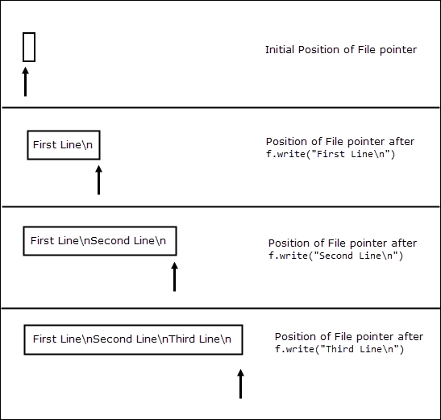
Note that unlike print() function, write() method do not print newline character (\n) at the end of string automatically. We can also use print() function to write data to the file. Let's take a closer look at the signature of the print() using the help() function.
1  2  3  4  5  6  7  8  9  10  11  12  13  14  15 | >>>  >>> help(print)  Help on built-in function print in module builtins:  print(...)  print(value, ..., sep=' ', end='\n', file=sys.stdout, flush=False)  Prints the values to a stream, or to sys.stdout by default.  Optional keyword arguments:  file: a file-like object (stream); defaults to the current sys.stdout.  sep: string inserted between values, default a space.  end: string appended after the last value, default a newline.  flush: whether to forcibly flush the stream.  >>>
Notice the fourth parameter in the function signature i.e file. By default, file points to the standard output means it will print data to the screen. To output data to a file just specify the file object. The following program uses print() function instead of write() to write data to the file.
python101/Chapter-18/writing_data_using_print_function.py
1  2  3  4  5  6  7 | f = open("readme.md", "w")  print("First Line", file=f)  print("Second Line", file=f)  print("Third Line", file=f)  f.close()
This program produces the same output as before, the only difference is that, in this case the newline character (\n) is automatically added by the print() function.

